Manufacturer’s Representative and Affiliate Appreciation Night. Tuesday 6-10-25
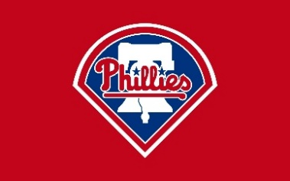

- Open to ALL Engineers and Designers.
- Limited to (2) Participants Per Rep. Agency/Philadelphia Chapter Affiliate.
- Must Provide Valid Email Address and Contact Number to Receive Event Ticket. Digital Tickets will be Emailed to Attendees. Uses BALLPARK App.
- Reservations to be Confirmed Prior to Issuance of Ticket.
- Event Sponsored by ASPE-Philadelphia - *Parking is NOT Included. (Attendees to Pay for Parking)
- Entering the park:
Guests may enter through the private Suite & Club Entrance-Home Plate on Pattison Avenue, or through the entrance closest to your suite:
• The Bill Giles Suite is on the 3rd Base Side: the Suite & Club Entrance–West, Third Base Gate, and Left Field Gate are convenient entrances.
For Additional Info Visit:
https://www.mlb.com/phillies/ballpark/information/health-safety-protocols
- Contact Info:
Chris Eyrich ceyrich@vbasales.com Cell: 267-328-7778
*RSVP by May 26, 2025
**Stay for the Post Game Concert… Performing, Nate Smith**
https://www.mlb.com/phillies/tickets/specials/nate-smith-postgame-concert

